North Pacific Coast (WRIA 20)

SRFB 2023 Grant Round Application Packet

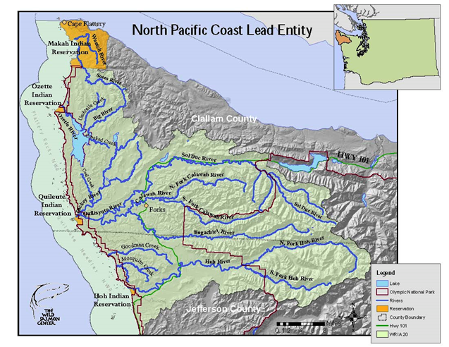The Salmon Recovery Funding Board (SRFB) has started its annual grant round. To submit a salmon habitat project application during this funding cycle you must contact your local Lead Entity for its application procedures and timelines.

NOTE: All applications must be submitted through a Lead Entity.

**PROJECT LOCATIONS**:

North Pacific Coast Lead Entity (NPCLE) projects must be located within the geographic boundary of Water Resource Inventory Area 20 (WRIA 20), which includes the highlighted portions of western Clallam and Jefferson counties and their nearshore as illustrated in the map above.

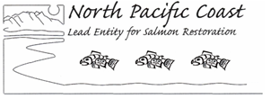

**BASIC APPLICATION PROCEDURE FOR 2023**

(Spring/Summer 2023)

(Applications must be entered online into PRISM after you get your Project # from the Lead Entity)

• Completed Conceptual Project Forms must be submitted to the Lead Entity by **March 3, 2023.**

• To get a PRISM Project Number contact the North Pacific Coast (WRIA 20) Lead Entity Coordinator, Anna Geffre, Northwest Indian Fisheries Commission, 549 Tillicum Lane*,*Forks, WA 98331. Phone: (360) 438-1180 ext. 575. Email: ageffre@nwifc.org.

• Go to the RCO website after you have a Project Number from the Lead Entity: <https://rco.wa.gov/grant/salmon-recovery/>.

**General Instructions:**

1. Fill out the Coast Salmon Partnership Habitat Restoration Conceptual Project Form (pages 7-10 of this application package) and submit it to NPCLE coordinator Anna Geffre at any time prior to the deadline. We will then enter the basics of your project into the Salmon Recovery Portal (SRP) and obtain a PRISM Project Number for you. This is accomplished by our Communications and Data Technician, Rebekah Brooks (rebekahbrookscontracting@gmail.com).
2. After you get your PRISM project number from the Lead Entity you will be able to fill in the rest of your information using the online grant program PRISM. Here is the PRISM link on how to apply: <https://rco.wa.gov/recreation-and-conservation-office-grants/apply-for-a-grant/prism/>.

Here are links to the official 2023 Salmon Recovery Grants Manual 18 (<https://rco.wa.gov/wp-content/uploads/2019/05/SAL-Manual18.pdf>) and application material <https://rco.wa.gov/grant/salmon-recovery/>. All required application forms and project proposal templates are included in Manual 18, and you may find links to all the forms and materials you will need in the Application Checklist as well.

Please check with the local salmon Lead Entity for their specific schedule of key dates, as it may differ slightly on some deadlines listed by SRFB <https://rco.wa.gov/wp-content/uploads/2019/10/SAL-GrantSchedule.pdf>. Specific NPCLE information can be found at <https://www.coastsalmonpartnership.org/north-pacific-coast-lead-entity/>.

Please contact Anna Geffre, 360-438-1180 ext. 575 ([ageffre@nwifc.org](mailto:ageffre@nwifc.org)) or Alissa Ferrell, 360-867-8618 (alissa.ferrell@rco.wa.gov) for clarification or assistance in getting your project information into PRISM.

**North Pacific Coast Lead Entity**

**SRFB 2023 Application Schedule**

(Winter-Spring 2023)

|  |  |
| --- | --- |
| **SCHEDULED ITEM** | **DATE** |
| **Official Release of the NPCLE SRFB Request for Proposals** (SRFB online application open January 9, 2023) | **January 5** |
| **DUE DATE: Conceptual project forms submitted to Lead Entity Coordinator.** | **March 3** |
| **NPCLE March meeting:**  Proposed project presentations with information available to NPCLE Technical and IG/Citizen Committee for initial review. | **March 21** |
| **DUE DATE: Complete applications submitted in PRISM two weeks prior to Site Visits.** | **Mar 29\*** |
| **SRFB Technical Review Panel Site Visit (may be virtual)** | **April 12-13\*** |
| **NPCLE April meeting.**  Presentations on all proposed projects submitted in PRISM | **April 18** |
| **NPCLE May meeting:**  Opportunity for presentations on proposal updates by project proponents. | **May 16** |
| **Comment forms received from SRFB Review Panel** | **May 24** |
| **NPCLE June meeting:**  Final Q & A between applicants and the Citizen and Technical Committees. Morning Technical Committee review of scoring criteria. | **June 20** |
| **DUE DATE: Final revised PRISM applications submitted for Lead Entity scoring and ranking.** | **June 26, noon** |
| **Technical Committee final project scoring session.** | **July 11** |
| **NPCLE July meeting:**  Citizens Committee/Initiating Governments rank and approve projects for submittal to RCO. | **July 18** |
| **Ranked project list submitted to SRFB by the Lead Entity Coordinator.** | **August 4** |

\**If only one day is needed for site visits, they will occur on April 13.*

The Salmon Recovery Funding Board (SRFB) also offers "Successful Applicant Workshops" that can be of great assistance in understanding the SRFB policies and project application and management procedures. All applicants and grant recipients are encouraged to attend workshops at least once every other year. A recording of the 2022 workshop can be found here: <https://www.youtube.com/watch?v=_xuICrW8X3Q&t=1s>.

**Successful Applicants:**

Successful applicants contact the Lead Entity in the location of their proposed project as early as possible so that stakeholders have plenty of time to be informed and potential partners can collaborate. Lead Entity Technical Committee members can be especially helpful in the early stages of project development.

**Overview of the SRFB 2023 Grant Round NPCLE Proposal Requirements:**

**(Applications must be completely submitted in PRISM by March 29, 2023)**

Once on PRISM with your Project # (begin entering your project):

1. Roles of the project team.
2. A project description (1-2 pages maximum- it can be a standard "abstract" of 1-2 paragraphs but should specifically address how it benefits salmon and whether it is a "priority project" identified in the NPCLE Salmon Restoration Strategy or the Lake Ozette Sockeye Recovery Plan or some other publicly reviewed restoration strategy).
3. Estimated budget including 15% match (totals entered into PRISM, but details attached as a separate budget of expenses presented in any format preferred by the project applicant; see below).
4. Identification of the target salmon species affected by the project (entered into PRISM). Attach the following separate documents into the PRISM application (attaching a file in PRISM is accomplished by clicking on the "Attachments" tab at the top of the page):
5. Evidence that the project is part of a recovery plan or lead entity strategy (Identified on the NPCLE Form and/or "project description").
6. A project location map (Add as an attachment in PRISM).
7. A site or parcel map (Add as an attachment in PRISM).
8. A preliminary design plan or sketch for restoration projects (Add as an attachment in PRISM if appropriate to the type of project).

**NPCLE APPLICATION REVIEW CRITERIA:**

The general evaluation criteria used by the NPCLE Technical Committee and Citizen Committee in reviewing projects proposed for the 2023 SRFB Grant Round include:

Project Strategy Sediment Control

Project Method Connectivity

Habitat Quality Applicant is or has a project sponsor

Habitat Quantity Likelihood of satisfying the granting agency

Salmonid Life Histories Accuracy of budget

Species Diversity (current) Urgency for immediate implementation

Riparian forest and native vegetation Qualifications

Local Community Support

(A copy of the form used by technical reviewers for proposal evaluation follows on the next pages)

**Table 1. Project Ranking Matrix**

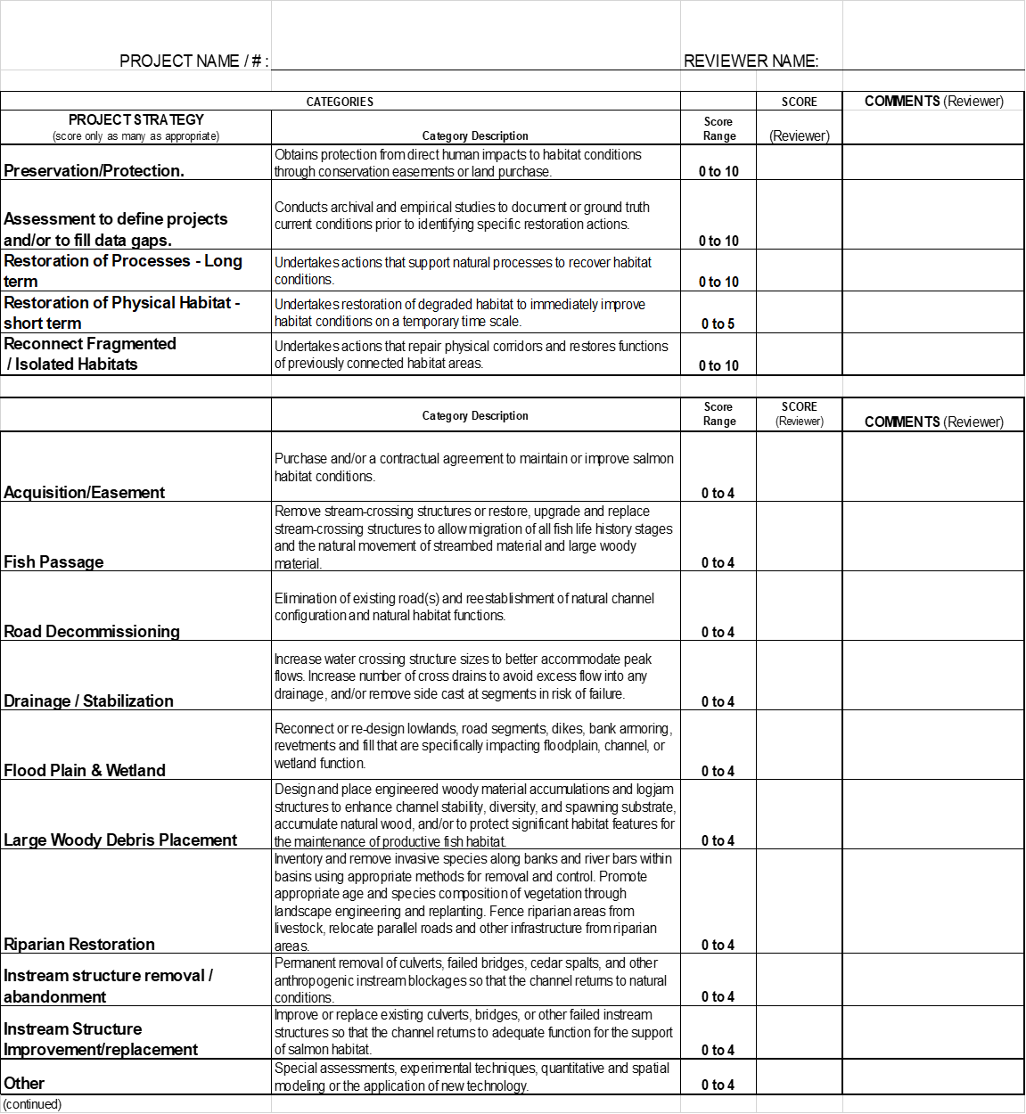





COAST SALMON PARTNERSHIP

HABITAT RESTORATION

CONCEPTUAL PROJECT FORM

|  |  |  |
| --- | --- | --- |
| **Project Information** | | |
| **Project Name** | |  |
| **Landowner** (name, phone number and/or email) | |  |
| **Project Type** (bank protection/ restoration/acquisition/etc.) | |  |
| **Project Sponsor or Primary Contact** (name, phone number and/or email) | |  |
| **Brief Project Description** |  | |
| **Current Land Ownership** (private, public, other) | |  |
| **Approximate Scale of Project to be Restored/Protected, if known** (linear feet, acreage, etc.) | |  |
| **Project Location** | |  |
| River or creek name, road crossing, nearest street address, if applicable | |  |
| Latitude/longitude | |  |
| Stream | |  |
| Sub-Basin | |  |
|  | |  |

|  |  |  |  |
| --- | --- | --- | --- |
| **Ecosystem Type to be Protected/Restored/Acquired** | | | |
|  | Estuary (River Delta) |  | Riparian (Stream side) |
|  | In-stream |  | Upland |
|  | Wetland |  | Off channel floodplain |
|  | Other____________________________ |  | N/A |

|  |  |  |  |
| --- | --- | --- | --- |
| **Resource Concerns Addressed (Choose All That Apply)** | | | |
|  | Bank erosion |  | Infrastructure protection |
|  | Flooding/flood control |  | Road maintenance |
|  | Stormwater runoff |  | Other _________________________________________ |

|  |  |  |  |
| --- | --- | --- | --- |
| **Habitat: Limiting Factor Addressed (Choose All that Apply)** | | | |
|  | Habitat diversity |  | Channel stability |
|  | Habitat composition |  | Width |
|  | Floodplain connectivity/function |  | Water quantity/flow |
|  | Fish Passage |  | Water quality |
|  | Predation |  | Sedimentation |
|  | Food |  | Temperature |
|  | Non-habitat limiting factors |  | Unknown |
|  | Channel structure and complexity |  | Other___________________________________ |
|  | | | |

|  |  |  |  |
| --- | --- | --- | --- |
| **Primary Aquatic Species Benefitting (Choose All that Apply)** | | | |
|  | Bull Trout |  | Rainbow Trout |
|  | Chinook |  | Sockeye |
|  | Chum |  | Steelhead |
|  | Coho |  | Cutthroat |
|  | Pacific lamprey |  | Mountain whitefish |
|  | Largescale sucker |  | Dace |
|  | Redside shiner |  | Northern pikeminnow |
|  | Sculpin |  | Three spine stickleback |
|  | Olympic mudminnow |  | Northern red-legged frog |
|  | Northwestern salamander |  | Long-toed salamander |
|  | Pacific Tree frog |  | Rough skin Newt |
|  | Migratory birds |  | Other___________________________________________ |
|  | | | |

|  |
| --- |
| **Detailed Project Information (where applicable)** |

|  |
| --- |
| **Additional Information** |
| **Does this project link to any other recently completed or proposed restoration or protection projects?** (List all projects related to water quality, quantity, habitat, barriers, etc.) |
|  |
| **Is there current or future potential landowner willingness to have a project done on this land?** |
|  |
| **Would there be any educational opportunities associated with this project?** |
|  |

|  |  |
| --- | --- |
| Problem Statement | *(What is the problem? What ecological concerns or limiting factors does the project address? For bank protection projects, what are the reach-scale and site specific causes of erosion (see Bank Erosion Strategy)? Are there any known potential constraints (infrastructure, access limitations, etc.) or other project considerations? Please include the chapter and section of a recovery plan where this action is recommended as well as the recovery plan goal to which the project relates.* |
| Goals and Objectives |  |
| Estimated Timeframe for Project Completion |  |
| Rough Cost |  |
| Estimate (required) |  |
| Partner(s) |  |
| If applicable, Secured Funding and Sources |  |

**Draw the project site**

What to include in your drawing: Rivers, creeks, land use around creek, roads or stream crossings, what you are proposing to do on this land, etc.

** Optional: Attach photographs, maps, supporting documents

**REFERENCES:**

Dlugokenski, C.E., W.H. Bradshaw,and S.R. Hager. 1981. An investigation of the limiting factors to Ozette sockeye salmon production and a plan for their restoration U.S. Fish and “Wildlife Services, Fisheries Assistance office, Olympia, WA 52.p

Haggerty, M.J., Ritchie, A.C., Shellberg, J.G., Crewson, M.J., and Jalonen, J. 2009. Lake Ozette Sockeye Limiting Factors Analysis. Prepared for the Makah IndianTribe and NOAA Fisheries in Cooperation with the Lake Ozette Sockeye Steering Committee, Port Angeles, WA.

McMillan, J.R. and J.C. Starr, 2008. Identification and prioritization of salmon tributaries for conservation in the Hoh River basin, Washington State. Wild Salmon Center, Portland, Oregon.

(available on HWS: http://hws.ekosystem.us)

NOAA, 2009. Lake Ozette Sockeye ESA Recovery Plan. Final plan approved May 9th, 2009. http://www.nwr.noaa.gov/Salmon-Recovery-Planning/Recovery-Domains/Puget-Sound/Lake-Ozette-Plan.cfm).

North Pacific Coast Lead Entity (NPCLE), 2007. North Pacific Coast Lead Entity

2007 Initial Habitat Strategy for Salmonid Projects Considered within WRIA 20. Unpublished Report. NPCLE, Port Angeles, WA, 71 p. (available on HWS: http://hws.ekosystem.us)

North Pacific Coast Lead Entity (WRIA 20) 2010-2019 Salmon Restoration Strategies. NPCLE, Forks WA, 75+ p. (<http://hws.ekosystem.us> ).

Roni, P., T. J. Beechie, R. E. Bilby, F. E. Leonetti, M. M. Pollock, and G. R. Pess, 2002. A Review of Stream Restoration Techniques and a Hierarchical Strategy for Prioritizing Restoration in Pacific Northwest Watersheds. North American Journal of Fisheries Management 22:1–20.

Roni, P., T.J. Beechie, and G.R. Pess, 2003. Prioritizing potential restoration actions within watersheds. Pages 60 – 73 in Beechie, T.J., E.A. Steel, P. Roni, and E. Quimby (editors). Ecosystem recovery planning for listed salmon: an integrated assessment approach for salmon habitat. U.S. Dept. Commerce, NOAA Technical Memo. NMFS-NWFSC-58.

Smith, Carol J., 2000. Salmon and Steelhead Habitat Limiting Factors in the North Coastal Streams of WRIA 20. Washington State Conservation Commission, Lacey, Washington State. 147 p. <http://docs.streamnetlibrary.org/Washington/ConservationCommission/Statewide_LFA_Final_Report_2005.pdf>.

Washington Department of Fish and Wildlife (WDFW), 2002. Salmonid Stock Inventory.

WDFW, Olympia, WA. Available online: http://wdfw.wa.gov/fish/sasi/.

Washington State Forest Practices Board (WFPB), 2001. Forest and Fish Plan.

Washington Department of Natural Resources (WDNR), Olympia, WA. Available online: http://www.forestandfish.com.

Water Resource Inventory Area (WRIA) 20 Implementation Body, 2010. WRIA 20 Detailed Implementation Plan. Approved for public review on March 24th, 2010.

Available on Clallam County website: <http://www.clallam.net.environment/watershed.html> under WRIA 20 Sol Duc-Hoh.

Water Resource Inventory Area (WRIA) 20 Planning Unit, 2008. Water Resource Inventory Area (WRIA 20) Watershed Management Plan. Prepared for final approval by the WRIA 20 Initiating Governments. Available online: <http://www.clallam.net.environment/watershed.html> under WRIA 20 Sol Duc-Hoh.