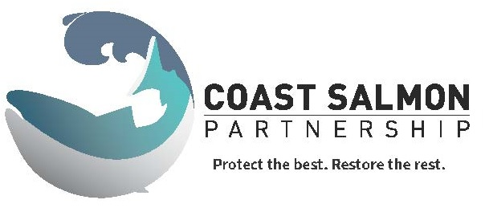

COAST SALMON PARTNERSHIP

HABITAT RESTORATION

CONCEPTUAL PROJECT FORM

Project Information
Project Name
Landowner (name, phone number and/or email)
Project Type (bank protection/ restoration/acquisition/etc.)
Project Sponsor or Primary Contact (name, phone number and/or email)
Brief Project Description
Current Land Ownership (private, public, other)
Approximate Scale of Project to be Restored/Protected, if known (linear feet, acreage, etc.)
Project Location
River or creek name, road crossing, nearest street address, if applicable
Latitude/longitude
Stream
Sub-Basin |  | Willapa Bay Watershed
COST ESTIMATE
(required)

(Please give some kind of “ball park” total estimate)

Ecosystem Type to be Protected/Restored/Acquired
 | Estuary (River Delta) |  | Riparian (Stream side)
 | In-stream |  | Upland
 | Wetland |  | Off channel floodplain
 | Other___________________________________________ |  | N/A

Resource Concerns Addressed (Choose All That Apply)
 | Bank erosion |  | Infrastructure protection
 | Flooding/flood control |  | Road maintenance
 | Stormwater runoff |  | Other ________________________________________________

Habitat: Limiting Factor Addressed (Choose All that Apply)
 | Habitat diversity |  | Channel stability
 | Habitat composition |  | Width
 | Floodplain connectivity/function |  | Water quantity/flow
 | Fish Passage |  | Water quality
 | Predation |  | Sedimentation
 | Food |  | Temperature
 | Non-habitat limiting factors |  | Unknown
 | Channel structure and complexity |  | Other________________________________________________

Primary Aquatic Species Benefitting (Choose All that Apply)
 | Bull Trout |  | Rainbow Trout
 | Chinook |  | Sockeye
 | Chum |  | Steelhead
 | Coho |  | Cutthroat
 | Pacific lamprey |  | Mountain whitefish
 | Largescale sucker |  | Dace
 | Redside shiner |  | Northern pikeminnow
 | Sculpin |  | Threespine stickleback
 | Olympic mudminnow |  | Northern red-legged frog
 | Northwestern salamander |  | Long-toed salamander
 | Pacific Treefrog |  | Roughskin Newt
 | Migratory birds |  | Other_________________________________________________

Additional Information

Does this project link to any other recently completed or proposed restoration or protection projects? (List all projects related to water quality, quantity, habitat, barriers, etc.)

Is there current or future potential landowner willingness to have a project done on this land?

Would there be any educational opportunities associated with this project?

Detailed Project Information (where applicable)
Problem Statement | (What is the problem? What ecological concerns or limiting factors does the project address? For bank protection projects, what are the reach-scale and site specific causes of erosion (see Bank Erosion Strategy)? Are there any known potential constraints (infrastructure, access limitations, etc.) or other project considerations? Please include the chapter and section of a recovery plan where this action is recommended as well as the recovery plan goal to which the project relates.
Goals and Objectives
Estimated Timeframe for Project Completion
Rough Cost Estimate
(required)
If applicable, Secured Funding and Sources
Partner(s)

Draw the project site

What to include in your drawing: Rivers, creeks, land use around creek, roads or stream crossings, what you are proposing to do on this land

**Optional: Attach photographs, maps, supporting documents

